**Final activity: Chicago Crime Scenario**

Contents

Objective 3

* 1. Chicago Crime Scenario 3
  2. Addressing Chicago Crime Scenario using AML 4
  3. Dataset Details on Azure Blob Storage 4

**Objective**

This exercise is intended for End-to-End Azure Machine Learning exercise. You will need to work on the given case study and follow below steps,

1. Use the data sources from Azure Blob Storage.
2. Find the type of Business problem we are trying to solve.
3. Clean & Transform your data.
4. Create, Train, Test your model.
5. Evaluate all other possible models and pick the best out of various metrics.
6. Publish your model as Web Service.
7. Use shared LIVE data to predict Arrest for 4 new cases.
8. Share your prediction results of LIVE data with the Trainer.
9. Share your AML Workspace with the Trainer’s Live ID

# Chicago Crime Scenario

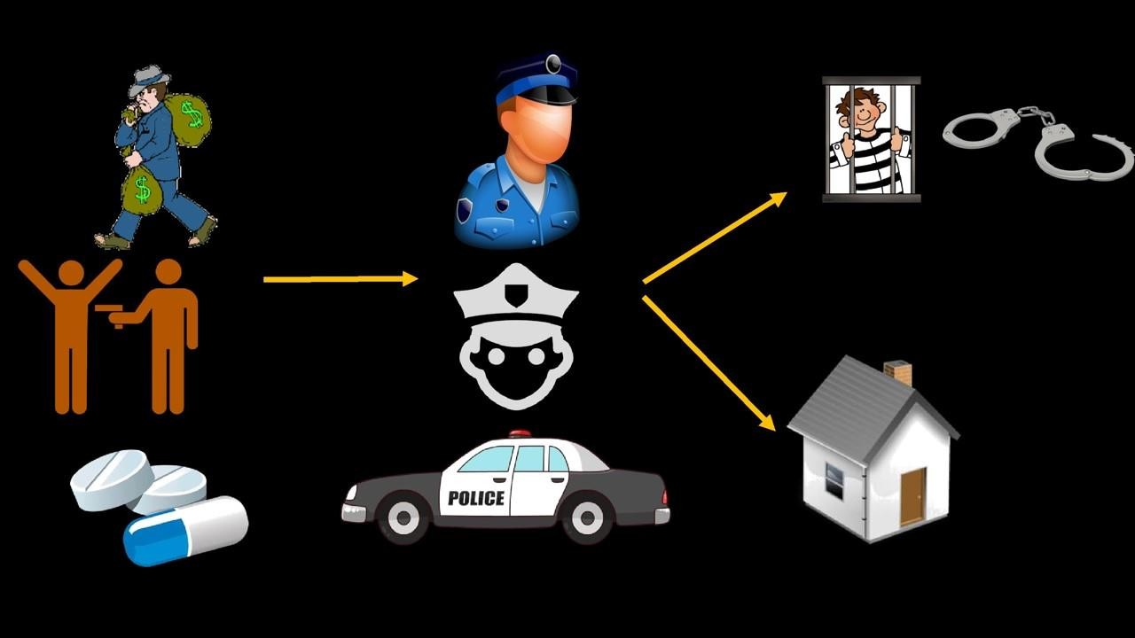

# Addressing Chicago Crime Scenario using AML

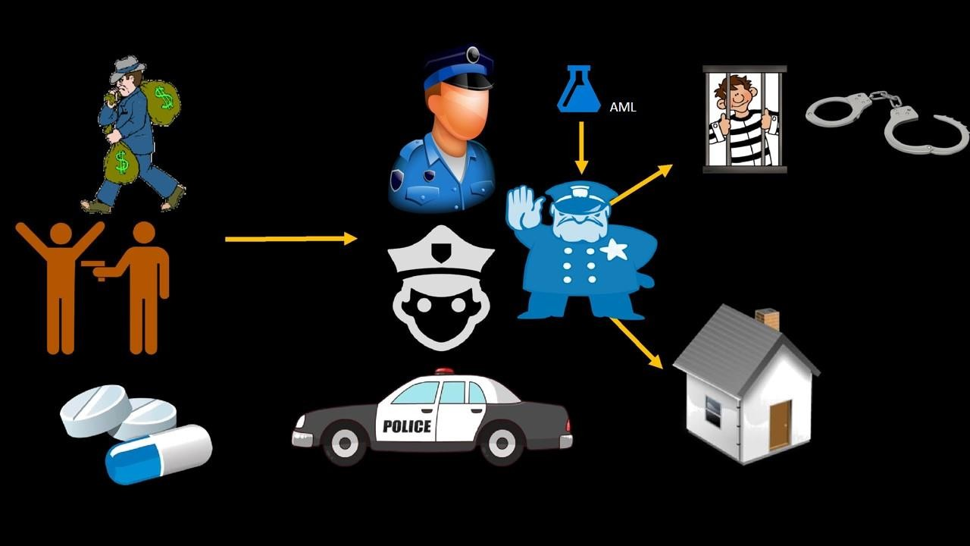

# Dataset Details on Azure Blob Storage

* **Data Source:** Azure Blob Storage
* **Authentication type**: Account
* **Account name**: nextgenanalytics2016
* **Account key:** YJ0ua9ECaHW9U9OSM5zOeGYxDUYoRTEYaX3AnSSet2jrShON0G4/ZfvI/cJGCAi/I6 PuLaB5ostGaxniWHbzpA==
* **Path to container, directory or blob:**
  + advancedanalytics/Chicago_Crime.csv
  + advancedanalytics/Chicago_Police_Department_-

_Illinois_Uniform_Crime_Reporting IUCR Codes.csv